**September 2023**

***Specials & Events***

**Events & Specials:**

**Sunday, September 3rd**

*National Tailgating Day! $1 off all bottled beer*

**Thursday, September 7th**

*-National Beer Lovers Day! Enjoy $5 Rainer Tall Boys!*

*-“Social Group Thursdays” welcomes NSE CPOA 3:30-6pm! Come mingle with other members of the chief petty officer association!*

**Saturday, September 9th**

*UFC 293! Adesanya vs. Strickland*

*(TBD Pending Availability)*

**Thursday, September 14th**

Karaoke Time! Come sing the night away!

**Saturday, September 16th**

National Batman Day! Enjoy the “Gotham City Martini” drink today for $5

**Monday, September 18th**

Pizza & Pints! $9 slice of pizza and 1 Coors Light draft beer

**Friday, September 22nd**

National Girls Night Out! $5 Cosmopolitan

**Monday, September 25th**

National Cooking Day! $1 off all appetizers

new

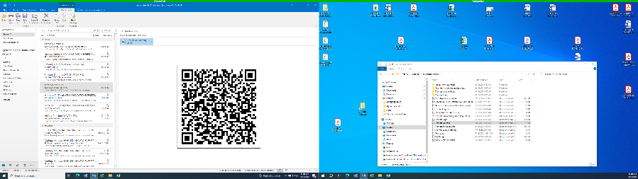

Scan QR code for menu & calendar

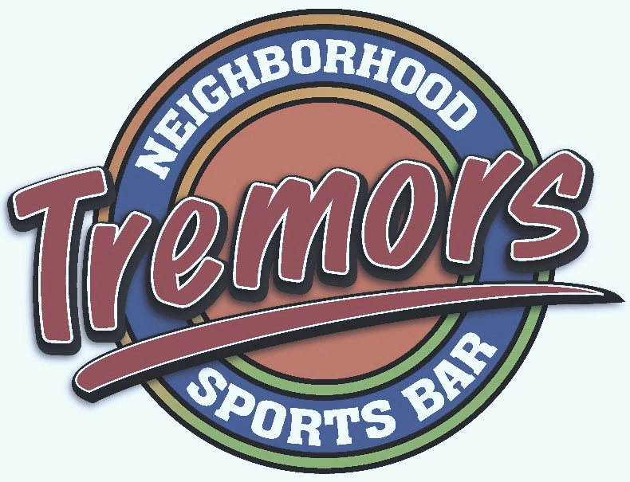

**Monthly Specials**

**Themed Drinks**

“Social Group Thursday” First Thursday of the month 3:30 – 6 pm

**Monthly Trivia Winner on Kahoots Leaderboard**

new



**Weekly specials**

**Mondays:** *Margarita Mondays*

**Thursdays**: *$5 Rainer tall boys*

**Fridays:** *Happy hour 9pm-12am*

new

All activities & specials are subject to change pending availability & staffing without notice

All events and specials are ***while supplies last***

All pricing, ingredients and availability are subject to change without notice